CHAPTER 2-2

nondeterministic finite state machines

- Nondeterminism means at each step of a computation, an automaton has a choice of moves to make.

Definition -- Nondeterministic FSM (NDFSM)

- A NDFSM is defined by the quintuple M=(K, Σ, Δ, s, A) where K, Σ, s, A are defined as for DFSM, but Δ is the transition relation from KX(Σ∪{ε}) to K.
- M accepts a string w iff at least 1 of its computations accepts.
- M rejects a string w iff none of its computation accepts.
- The language accepted by M, denoted L(M), is the set of all strings accepted by M.
- Consider the following:
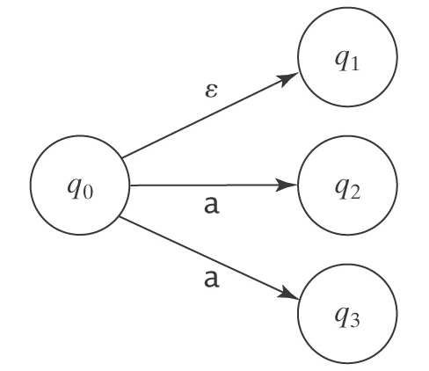
If M is in state q₀ and the next input is a, then there are 3 moves that M can make:

Ex2-2-1 The following NDFSM defines the language of all strings with a triple a followed by a triple b:
a a a b b b
+
-q0
q1

a,b a,b a,b

Ex2-2-2 L={w∈{a, b}*:w is made up of an optional a followed by aa followed by zero or more b’s}.

Ex2-2-3 L={w∈{a, b}*:w=aba or |w| is even}.

Why nondeterminism?

Ex2-2-4 Let LMissing={w: w does not contain all letters in the alphabet Σ, where Σ={a,b,c,d}}.
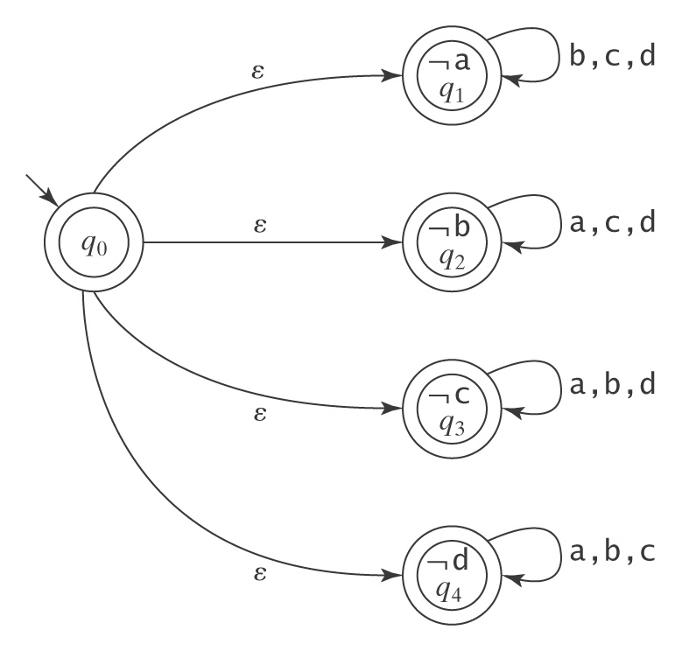
Ex2-2-5 L={w∈{a, b, c}*:∃x, y∈{a, b, c}*(w = xabcabby)}. In other words, w must contain at least 1 occurrence of the substring abcabb. The following DFSM M₁ accepts L:
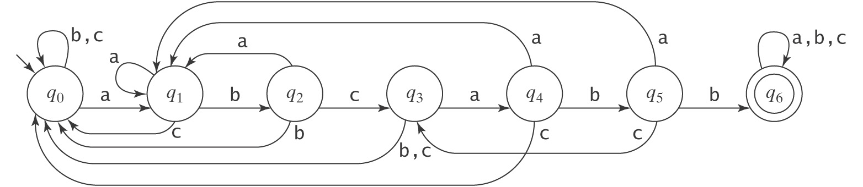

Ex2-2-6 L={w∈{a, b}*: ∃x, y∈{a, b}*:w=xabbaay or w=xbabay}.

Ex2-2-7 L = {w∈{a, b}*:the fourth to the last character is a}.

Ex2-2-8 What language does the following NDFSM accept?
a, b b

+

a
-
a, b a

+
b

Ex2-2-9 What language does the following NDFSM accept?
-

Ex2-2-10 What language does the following NDFSM accept?
±

Homework problems

  - Consider the following NDFSM M:
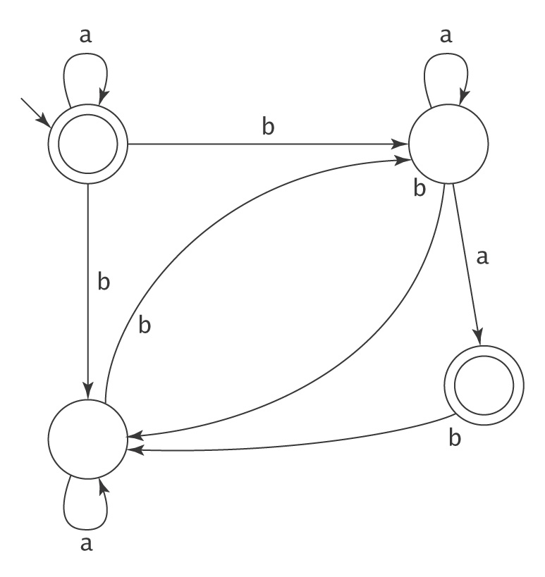
For each of the following strings w, determine whether w ∈ L(M):
  - aabbba.
  - bab.
  - baba.

- Show a nondeterministic FSM to accept each of the following languages:
  - {w ∈ {a, b}* : w contains at least one instance of aaba, bbb or ababa}.
  - {w ∈ {a, b, c, d, e}* : |w| ≥ 2 and w begins and ends with the same symbol}.

- Design an NDFSM with no more than 4 states for the set {a^{n}:n≥0}∪{b^{n}a:n≥1}.

- What language does the following NDFSM accept?
a, b b
-
+

